Case Study Domain –Education

focus – Data analysis

1. Read the three csv files which contains the score of same students in term1 for each Subject

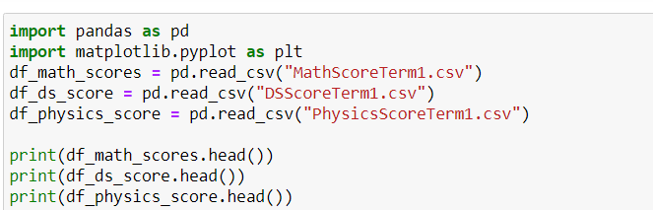

1. 2Remove the name and ethnicity column (to ensure confidentiality)

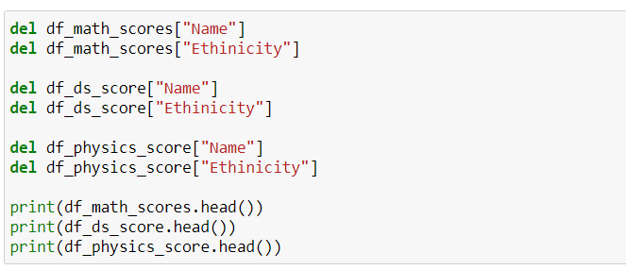

1. Fill missing score data with zero

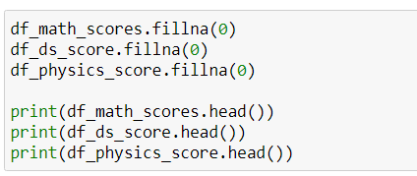

1. Merge the three files

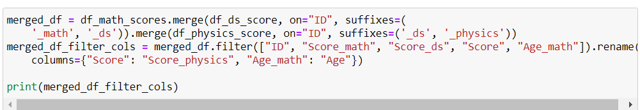

1. Change Sex(M/F) Column to 1/2 for further analysis

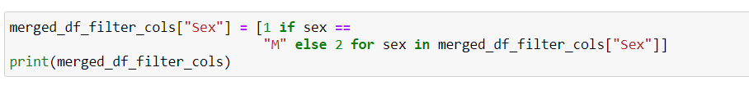

1. Store the data in new file –ScoreFinal.csv

